# CS 255 System Design Document

This template lays out all the different sections that you need to complete for Project Two. Each section has guidance to prompt your thinking. You will need to continually reference the interview transcript as you work to make sure that you are addressing your client’s needs. There is no required length for the final document. Instead the goal is to complete each section based on what your client’s needs are. Remove this note when you are finished, and replace all bracketed text with the relevant information.

## UML Diagrams

### UML Use Case Diagram

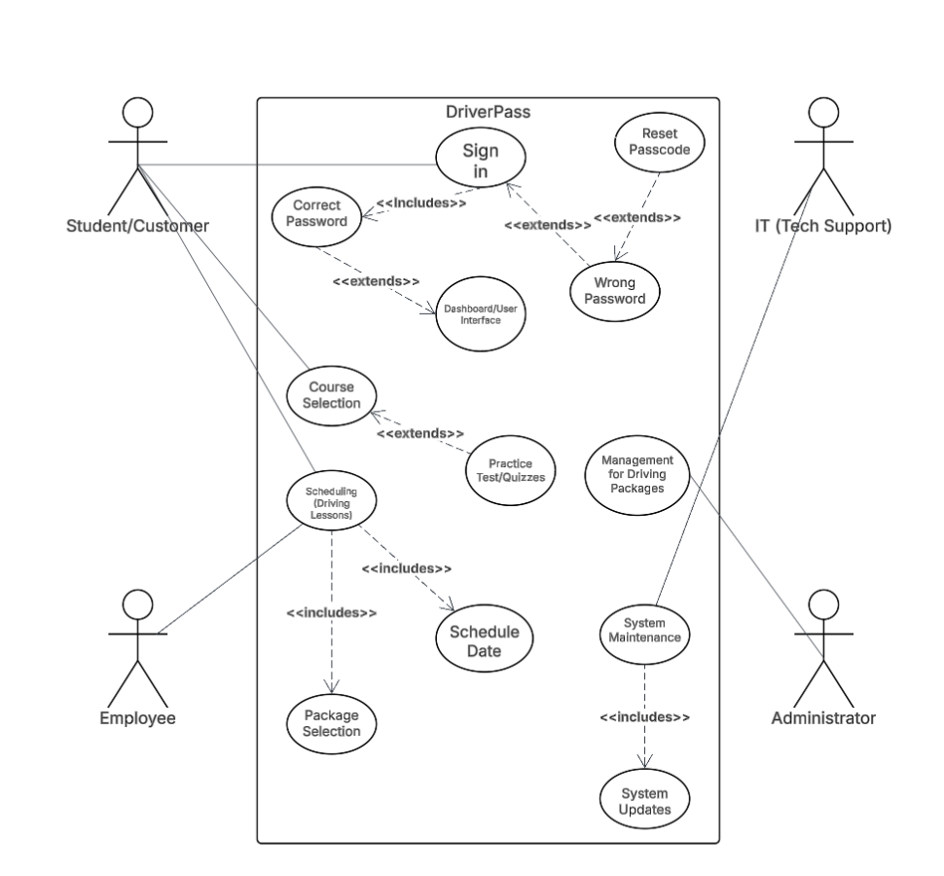

### UML Activity Diagrams

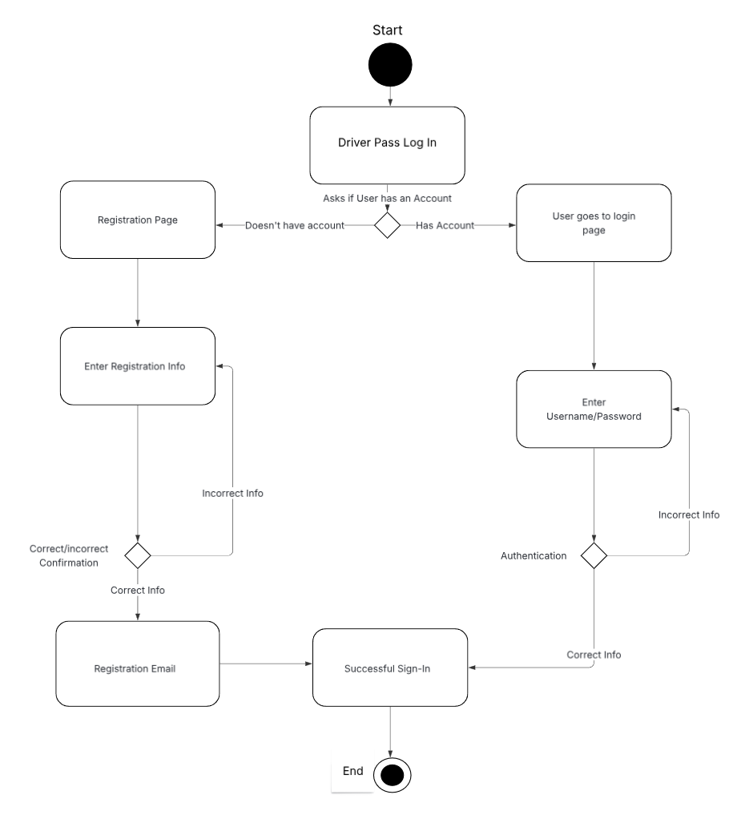

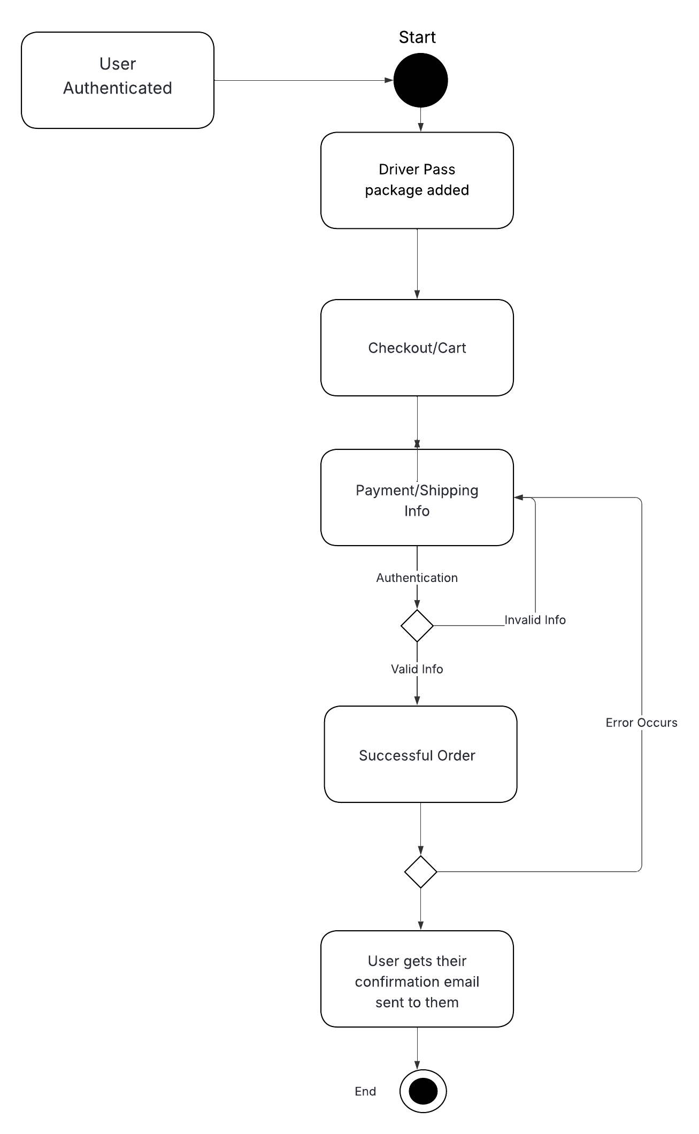

### UML Sequence Diagram

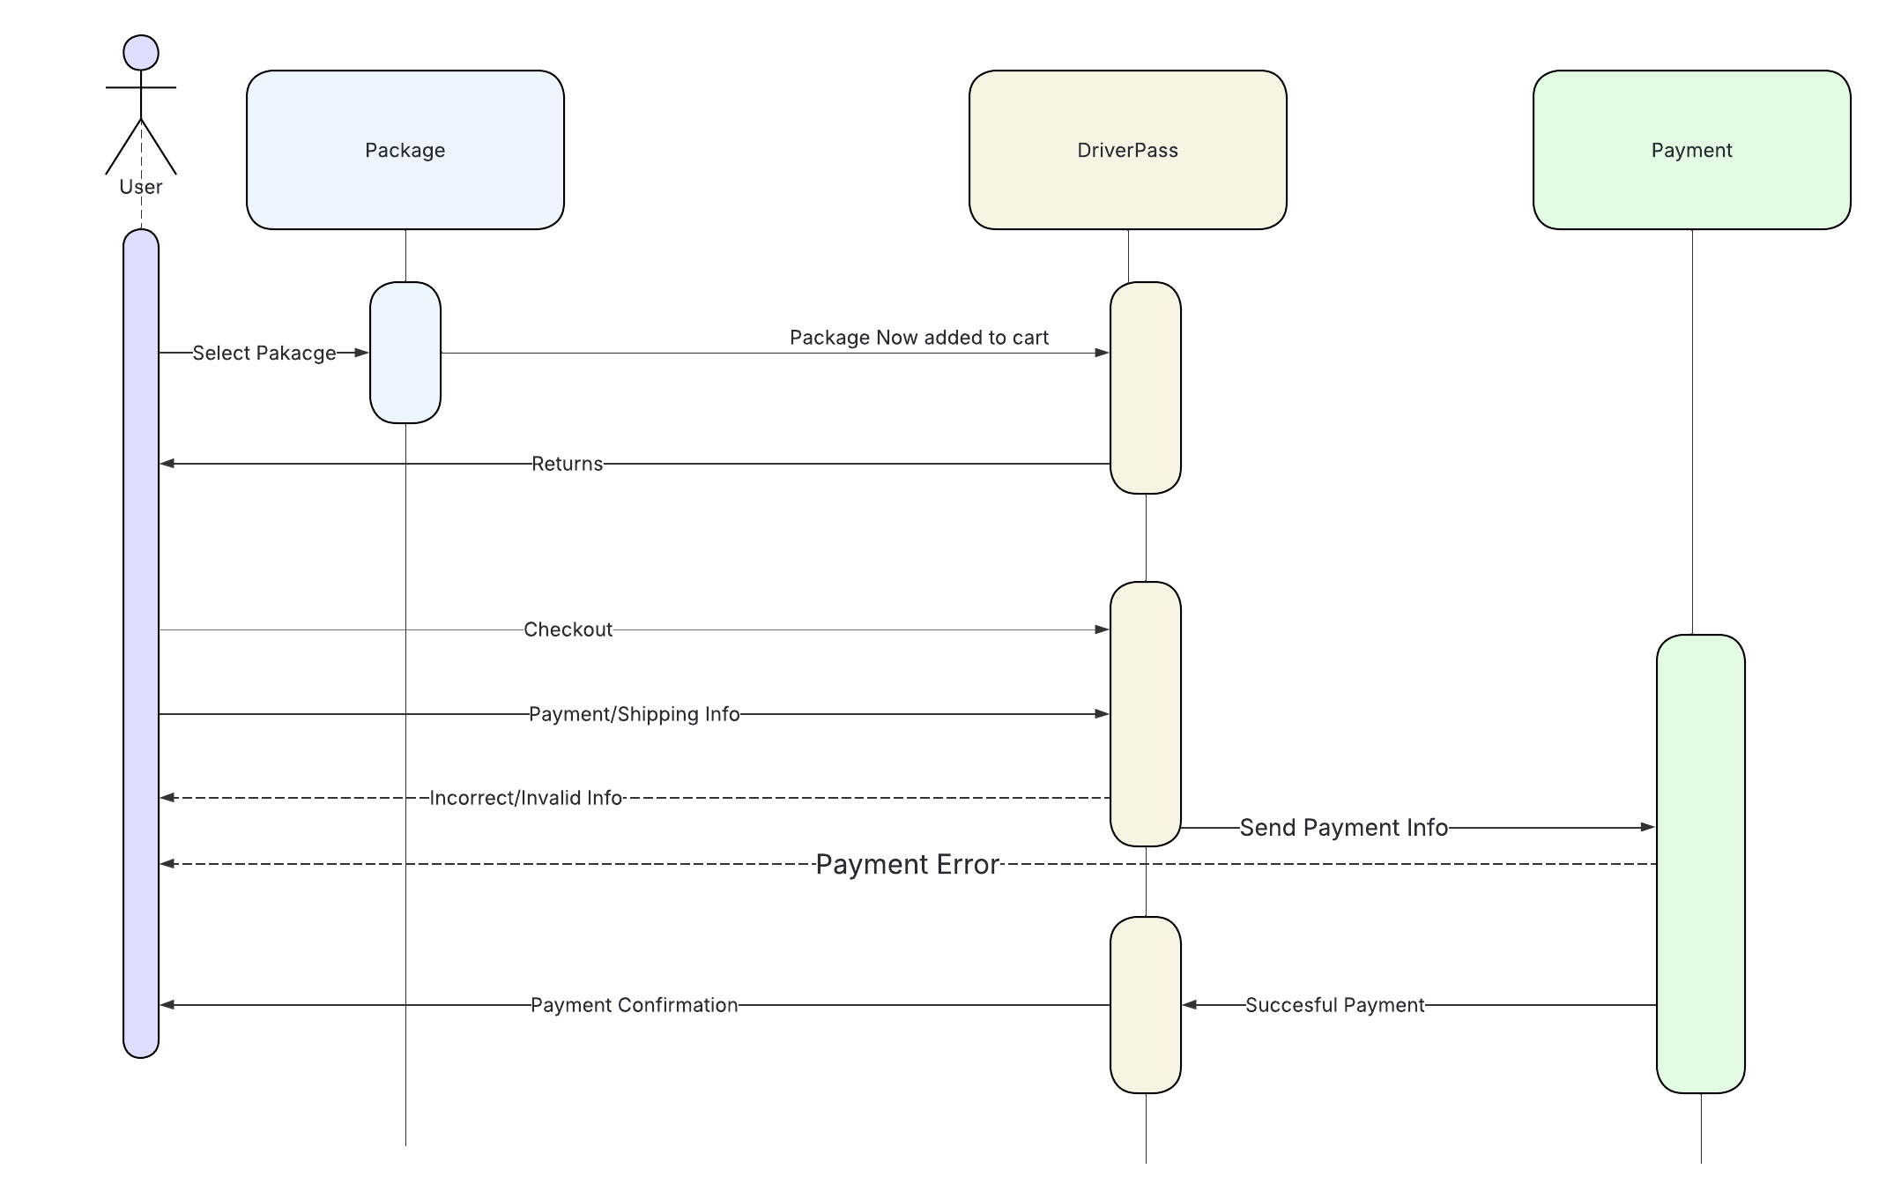

### UML Class Diagram

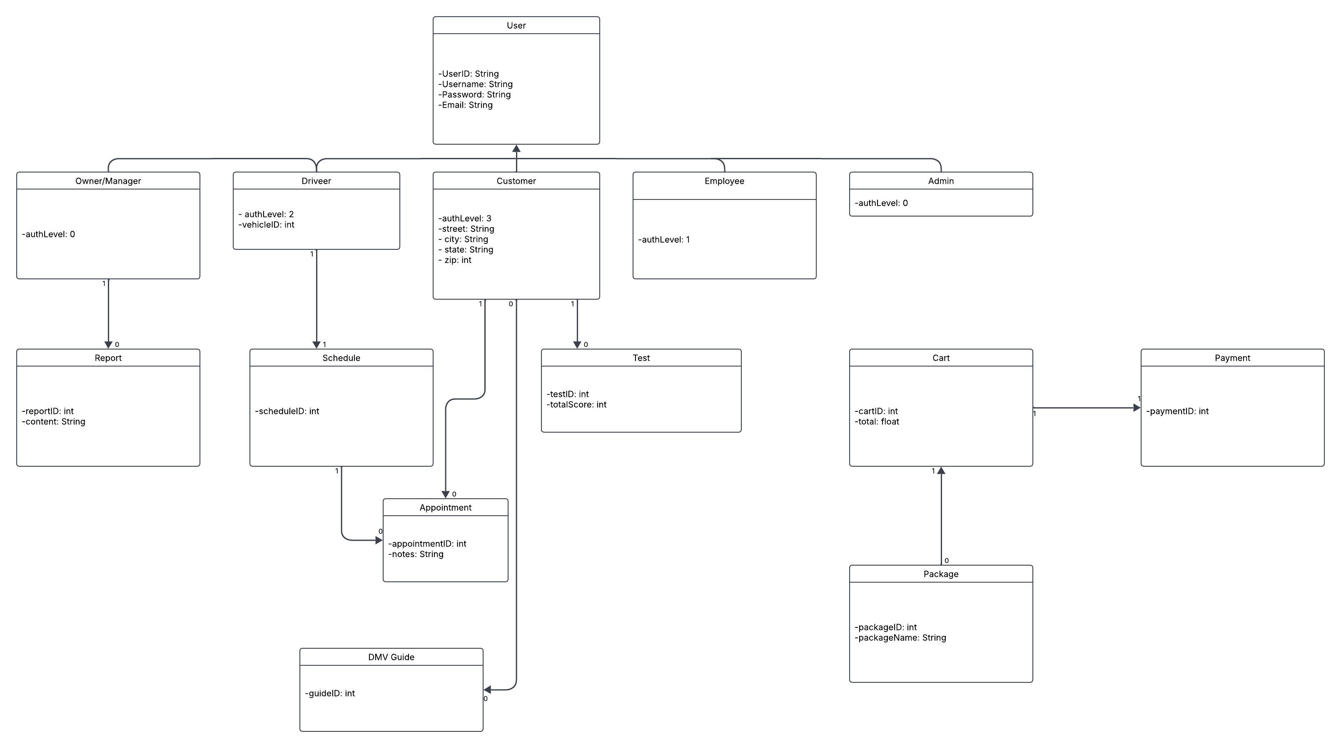

## Technical Requirements

Some hardware, software, tools, and infrastructure necessities include stable internet, computer/mobile device, and an efficient server. Other requirements are an SQL Server, security software to prevent any data breaches. Lastly, cloud services could come in handy as well for information handling. All these technical requirements should allow us to succeed to the best degree possible on our project.